A* - out of order tiles
start = (1, 3, 0, 4, 2, 5, 7, 8, 6)
goal = (1, 2, 3, 4, 5, 6, 7, 8, 0)
import heapq

class PuzzleState:
def __init__(self, board, g=0, parent=None, move=""):
self.board, self.g, self.parent, self.move = board, g, parent, move
goal = (1, 2, 3, 4, 5, 6, 7, 8, 0)
self.f = g + sum(1 for i in range(9) if board[i] != 0 and board[i] != goal[i])
def get_neighbors(self):
neighbors = []
z = self.board.index(0)
r, c = z // 3, z % 3
for dr, dc, m in [(-1,0,"Up"), (1,0,"Down"), (0,-1,"Left"), (0,1,"Right")]:
if 0 <= r+dr < 3 and 0 <= c+dc < 3:
nz = (r+dr) * 3 + (c+dc)
nb = list(self.board)
nb[z], nb[nz] = nb[nz], nb[z]
neighbors.append(PuzzleState(tuple(nb), self.g + 1, self, m))
return neighbors
def __lt__(self, other): return self.f < other.f

open_list = [PuzzleState(start)]
best_g = {start: 0}
exp = 0
found = None
while open_list:
curr = heapq.heappop(open_list)
if curr.g > best_g.get(curr.board, float('inf')): continue
exp += 1
if curr.board == goal:
found = curr
break
for n in curr.get_neighbors():
if n.board not in best_g or n.g < best_g[n.board]:
best_g[n.board] = n.g
heapq.heappush(open_list, n)

path = []
curr = found
while curr.parent:
path.append((curr.move, curr.board))
curr = curr.parent
path.reverse()

for i in range(0, 9, 3): print(f"{start[i]} {start[i+1]} {start[i+2]}")
print(f"\nSolved in {len(path)} moves. Total expanded nodes: {exp}\n")
for step, (move, board) in enumerate(path, 1):
print(f"Step {step}: Move {move}")
for i in range(0, 9, 3): print(f"{board[i]} {board[i+1]} {board[i+2]}")
print()
output:
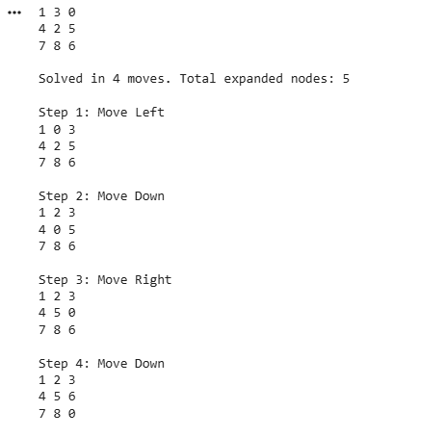
A* - manhattan distance
import heapq
class PuzzleState:
def __init__(self, board, g=0, parent=None, move=""):
self.board, self.g, self.parent, self.move = board, g, parent, move
self.f = g + self.calculate_manhattan()
def calculate_manhattan(self):
goal_pos = {1:(0,0), 2:(0,1), 3:(0,2), 4:(1,0), 5:(1,1), 6:(1,2), 7:(2,0), 8:(2,1), 0:(2,2)}
dist = 0
for i, val in enumerate(self.board):
if val != 0:
curr_row, curr_col = i // 3, i % 3
goal_row, goal_col = goal_pos[val]
dist += abs(curr_row - goal_row) + abs(curr_col - goal_col)
return dist
def get_neighbors(self):
neighbors = []
z = self.board.index(0)
r, c = z // 3, z % 3
for dr, dc, m in [(-1,0,"Up"), (1,0,"Down"), (0,-1,"Left"), (0,1,"Right")]:
if 0 <= r+dr < 3 and 0 <= c+dc < 3:
nz = (r+dr) * 3 + (c+dc)
nb = list(self.board)
nb[z], nb[nz] = nb[nz], nb[z]
neighbors.append(PuzzleState(tuple(nb), self.g + 1, self, m))
return neighbors
def __lt__(self, other): return self.f < other.f
def solve_8_puzzle(start):
open_list = [PuzzleState(start)]
best_g = {start: 0}
exp = 0
while open_list:
curr = heapq.heappop(open_list)
if curr.g > best_g.get(curr.board, float('inf')): continue
exp += 1
if curr.board == (1, 2, 3, 4, 5, 6, 7, 8, 0):
path = []
while curr.parent: path.append((curr.move, curr.board)); curr = curr.parent
return path[::-1], exp
for n in curr.get_neighbors():
if n.board not in best_g or n.g < best_g[n.board]:
best_g[n.board] = n.g
heapq.heappush(open_list, n)
def print_b(b):
for i in range(0, 9, 3): print(f"{b[i]} {b[i+1]} {b[i+2]}")
print()
start = (7, 2, 4, 5, 0, 6, 8, 3, 1)
print("Start State:"); print_b(start)
path, exp = solve_8_puzzle(start)
print(f"Solved in {len(path)} moves. Total expanded nodes: {exp}\n")
for step, (move, board) in enumerate(path, 1):
print(f"Step {step}: Move {move}"); print_b(board)
